**NAME: JEEVITHA.S-192324020**

**DATABASE MANAGEMENT SYSTEM FOR DATA APPLICATIONS(CSA0555)**

**ASSIGNMENT 5: VIEWS,SYNONYM AND SEQUENCE**

**VIEWS**

SELECT *FROM EMPLOYEE;

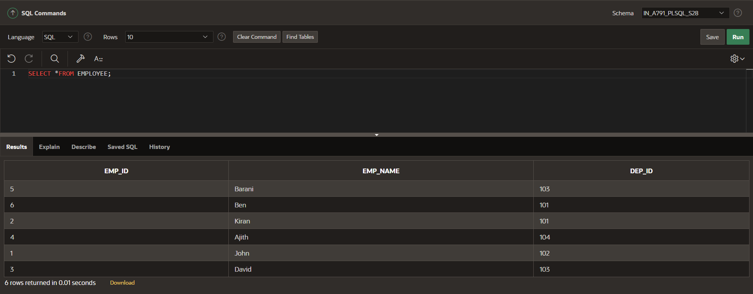

SELECT *FROM DEPARTMENT;

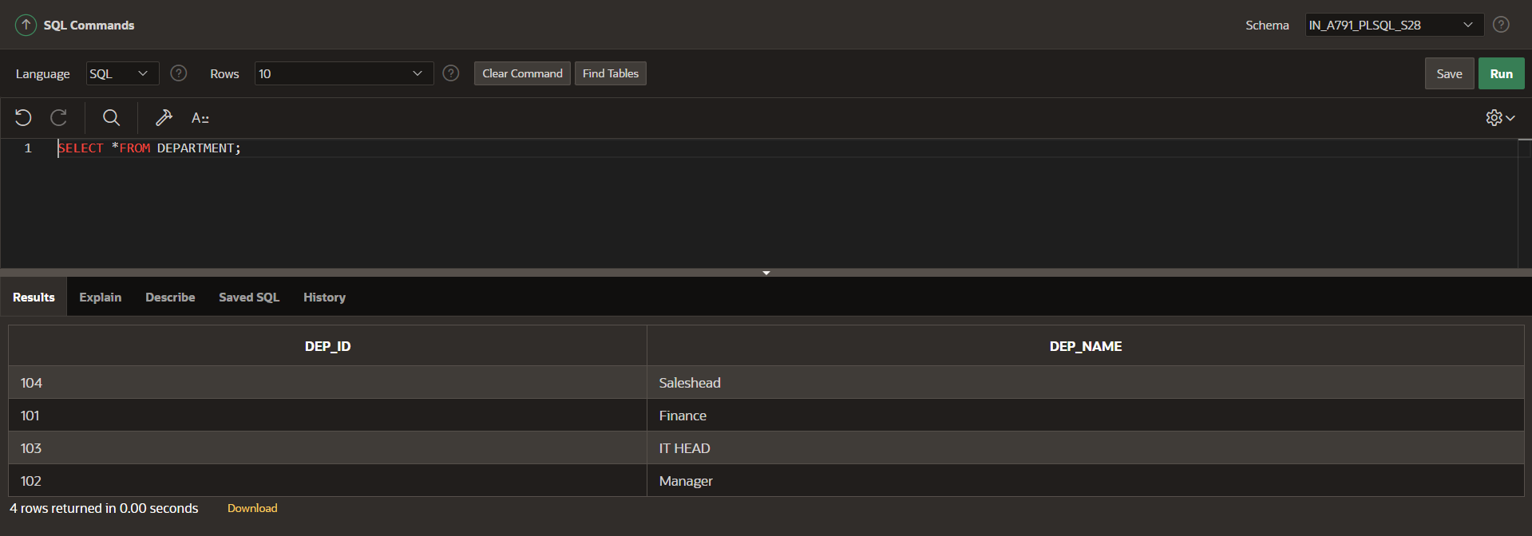

**INNER JOIN:**

SELECT EMP_ID,EMP_NAME,DEP_NAME FROM EMPLOYEE INNER JOIN DEPARTMENT ON EMPLOYEE.DEP_ID=DEPARTMENT.DEP_ID;

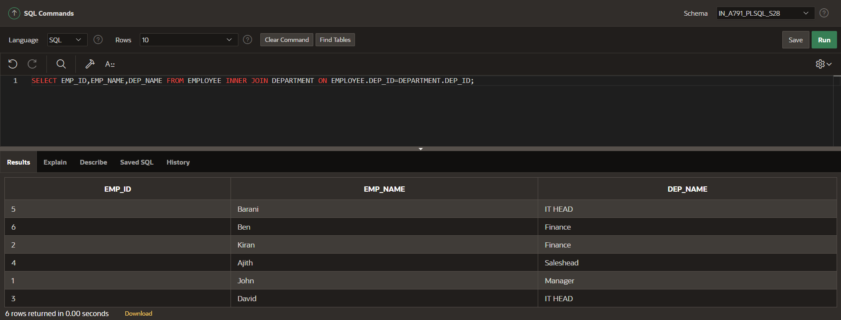

**CREATE VIEW EMP_DETAIL AS**

SELECT EMP_ID,EMP_NAME,DEP_NAME FROM EMPLOYEE INNER JOIN DEPARTMENT ON EMPLOYEE.DEP_ID=DEPARTMENT.DEP_ID;

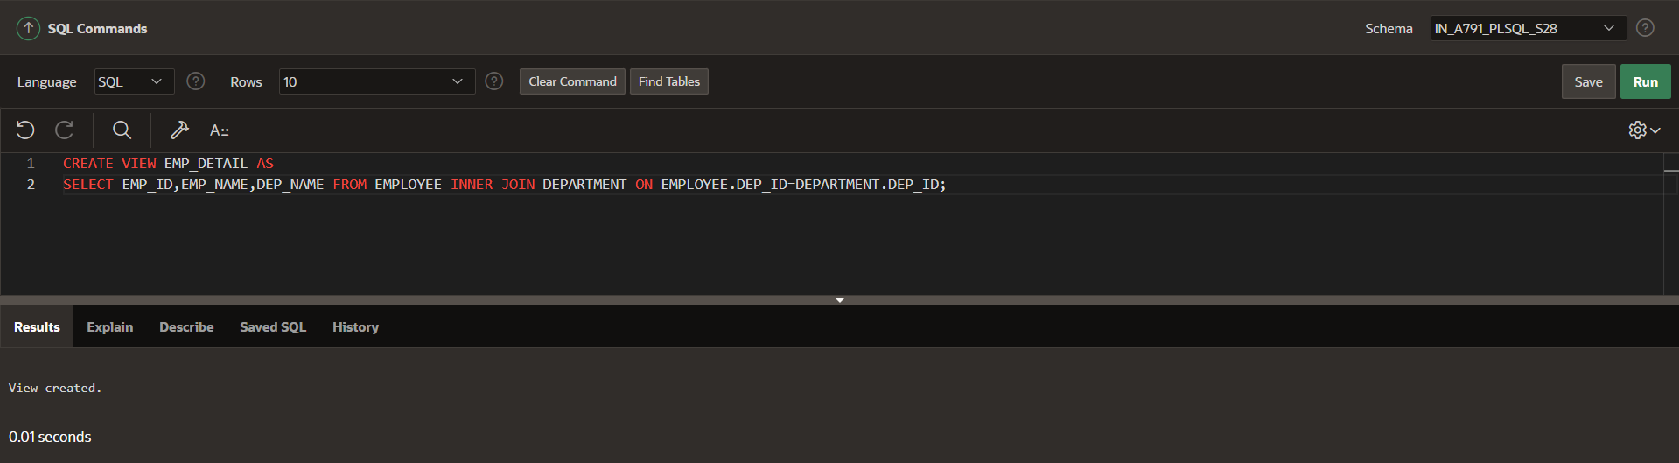

SELECT *FROM EMP_DETAIL;

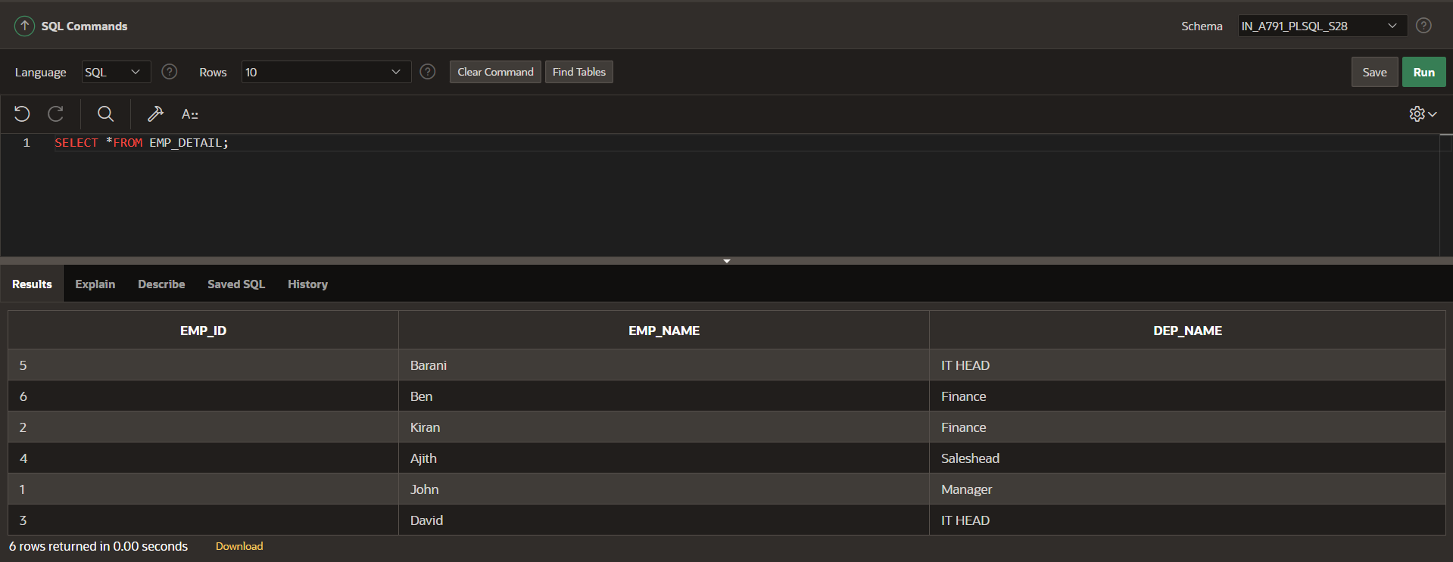

SELECT *FROM EMP_DETAIL WHERE DEP_NAME='Finance';

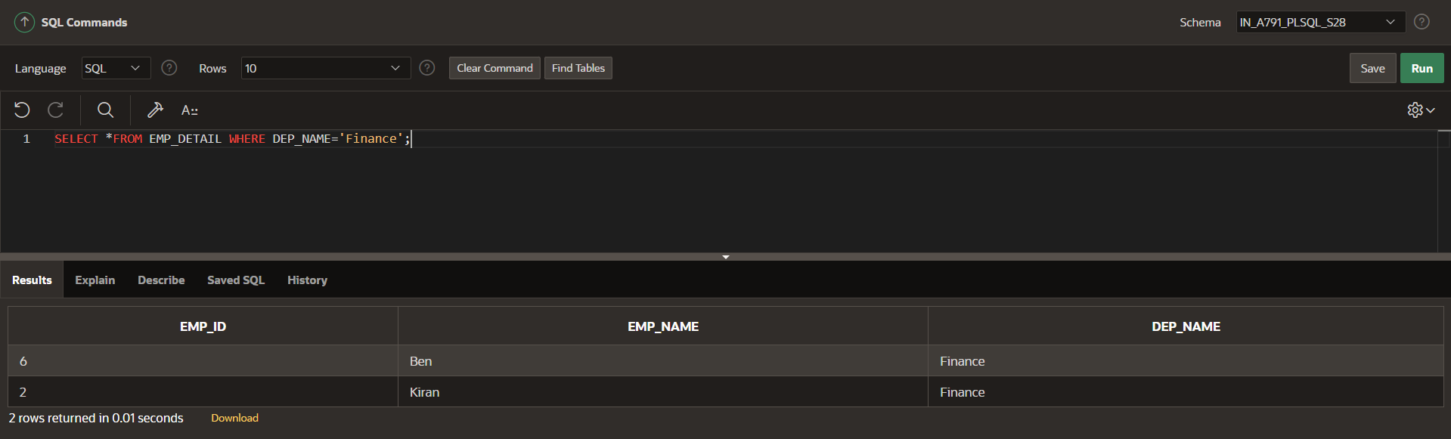

**CREATE OR REPLACE VIEW EMP_DETAIL AS**

SELECT EMP_ID,EMP_NAME,DEP_NAME FROM EMPLOYEE INNER JOIN DEPARTMENT ON EMPLOYEE.DEP_ID=DEPARTMENT.DEP_ID ORDER BY EMP_ID;

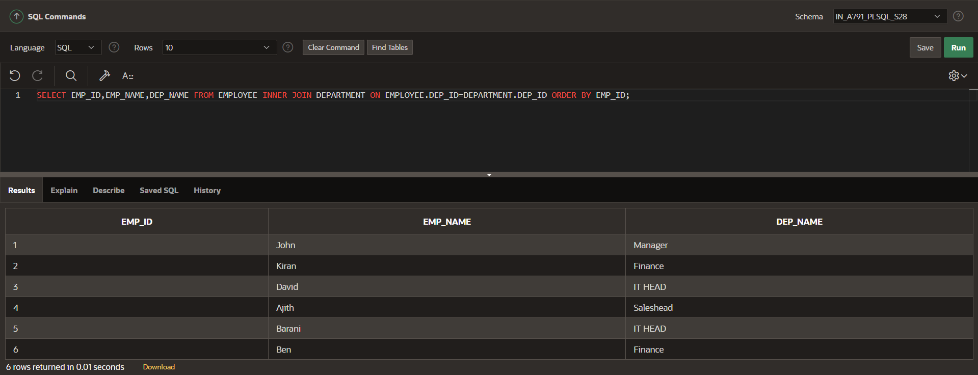

**DROP VIEW EMP_DETAIL;**

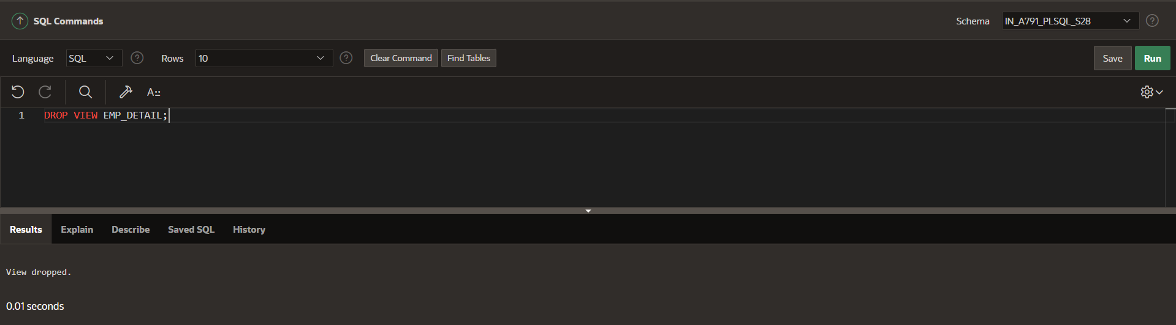

**SEQUENCE**

CREATE SEQUENCE seq1

START WITH 1

INCREMENT BY 1

MINVALUE 1

MAXVALUE 5;

SELECT seq1.nextval FROM dual;

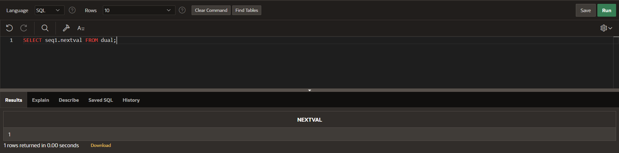

SELECT seq1.nextval FROM dual;

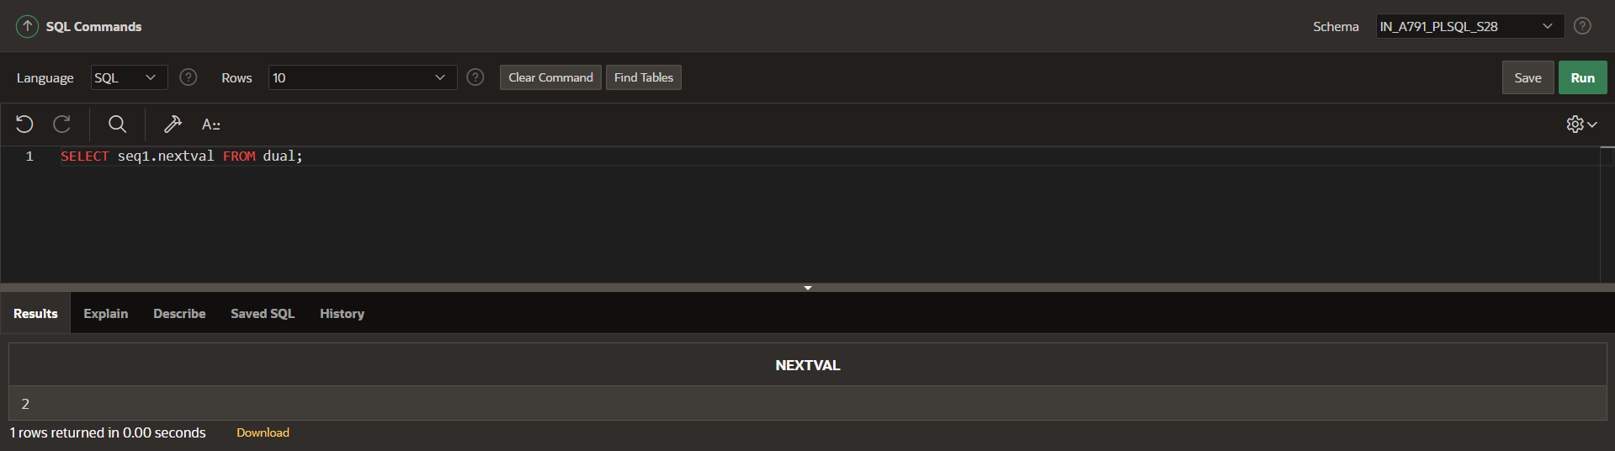

SELECT seq1.nextval FROM dual;

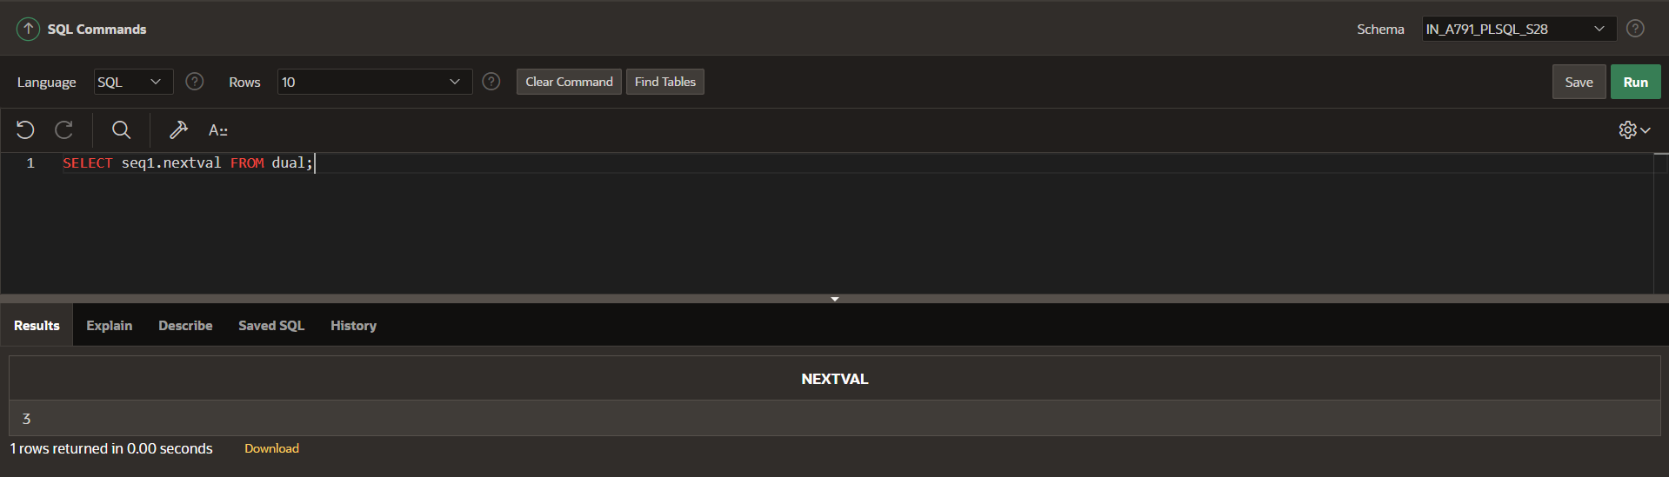

SELECT seq1.nextval FROM dual;

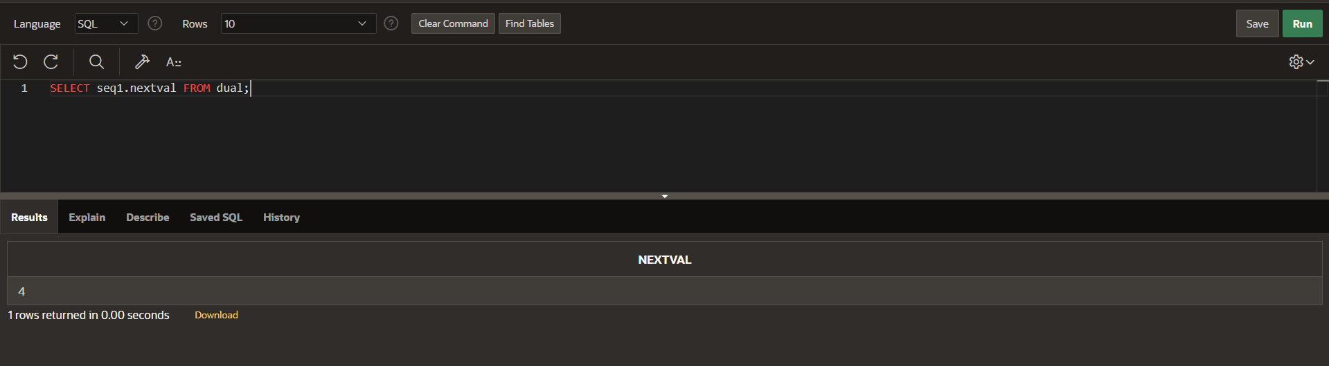

SELECT seq1.nextval FROM dual;

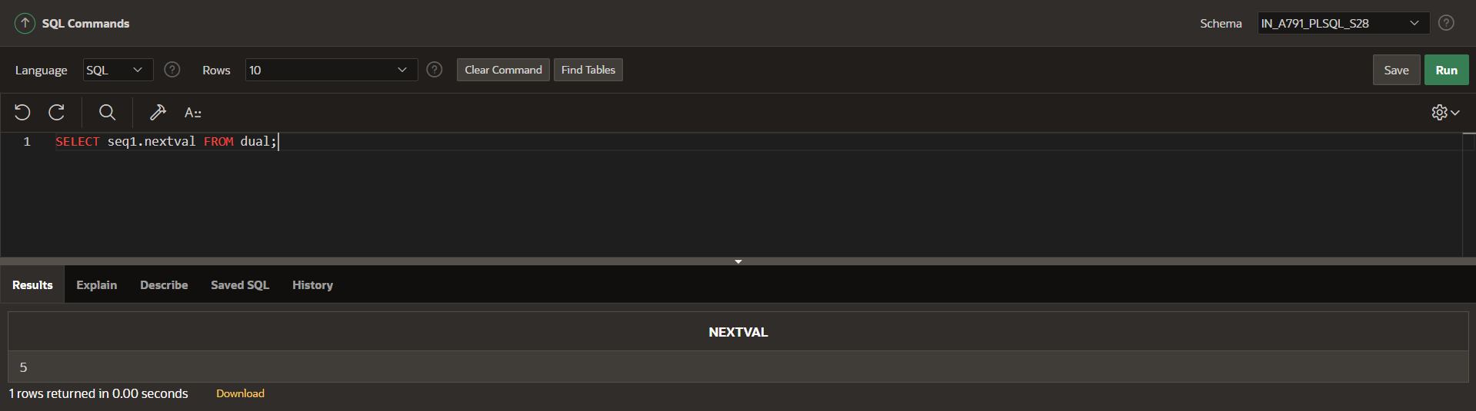

THE MAXVALUE SHOULD BE REACHED

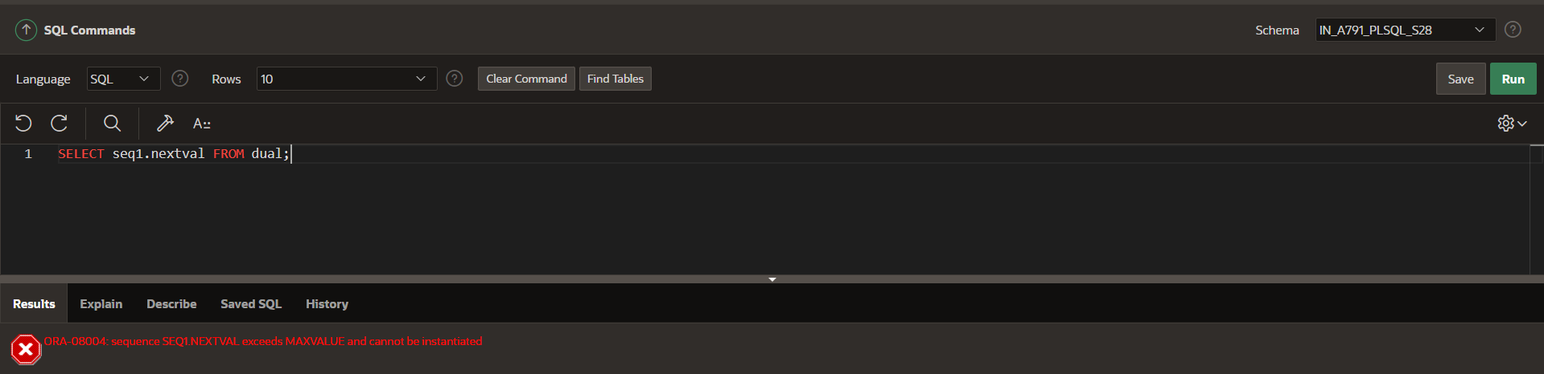

**DROP THE SEQUENCE**

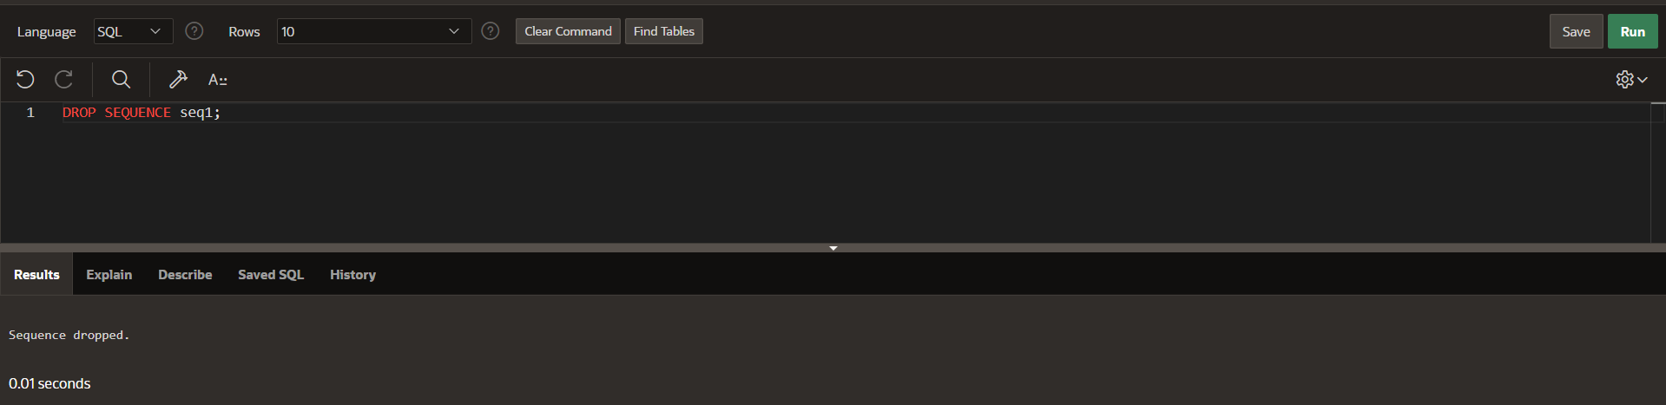

**YOU SHOULD CONTINUE THE SEQUENCE MUST FIND THE CACHE.**

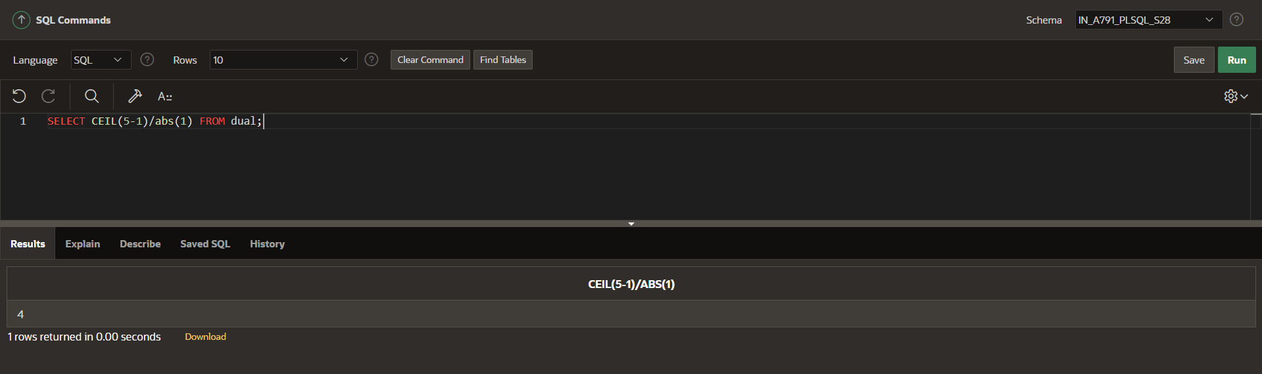

**AFTER**

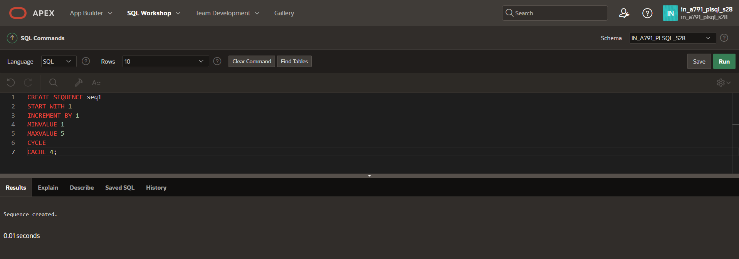

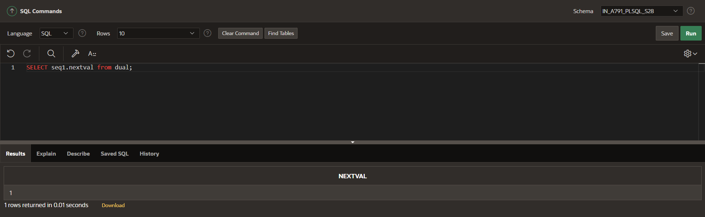

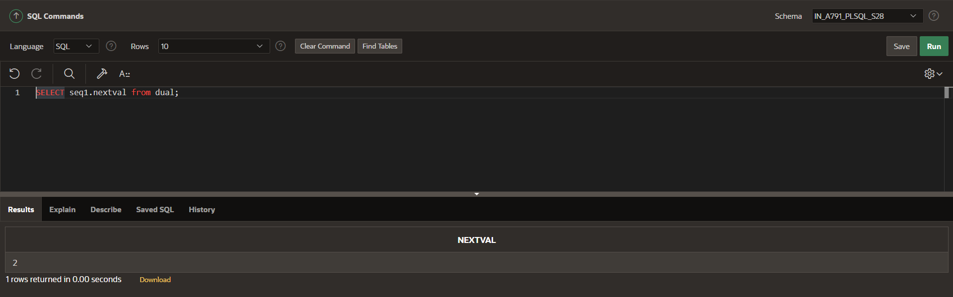

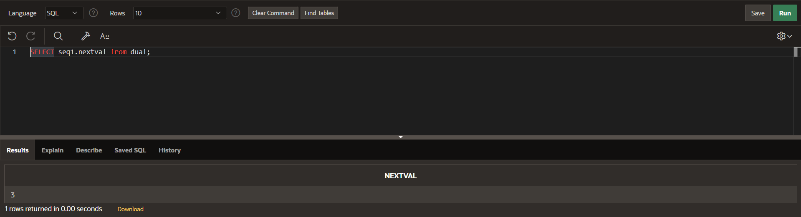

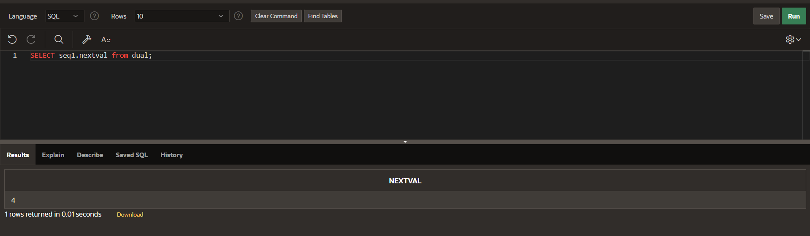

**CURRENT VALUE:**

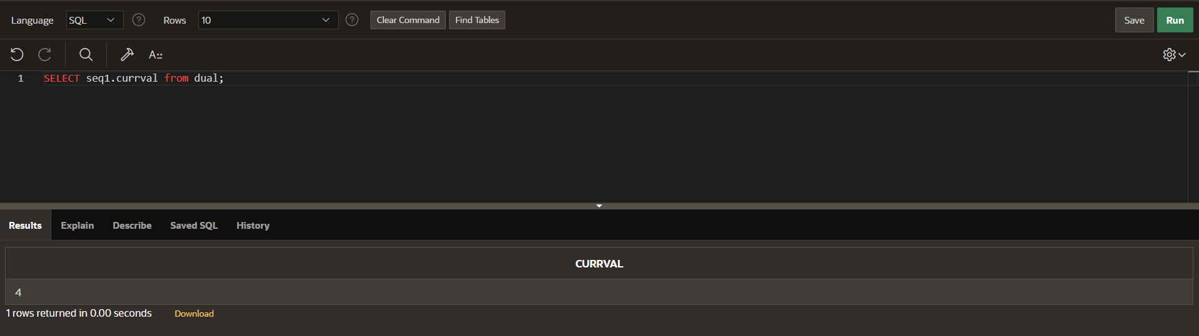

**NEXT VALUE:**

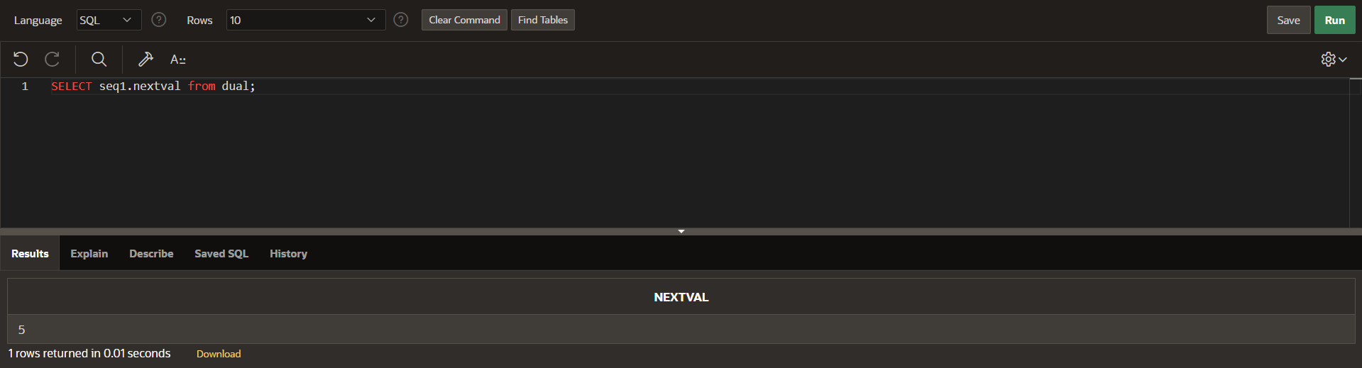

**IT START WITH 1 BECAUSE THE CYCLE AND CACHE ARE INVOLVED IN THE SYNTAX.**

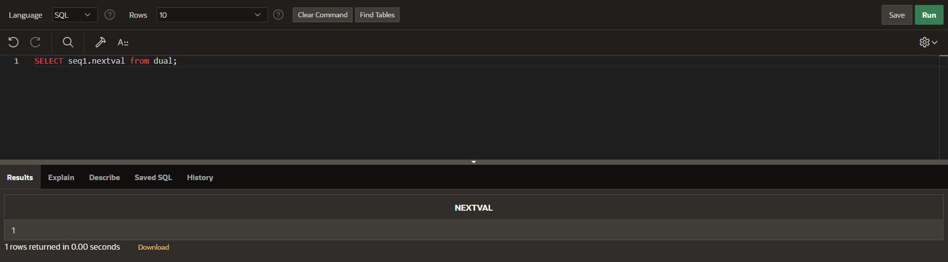

**SYNONYM**

SELECT *FROM STUDENT_DETAIL ORDER BY STU_ID;

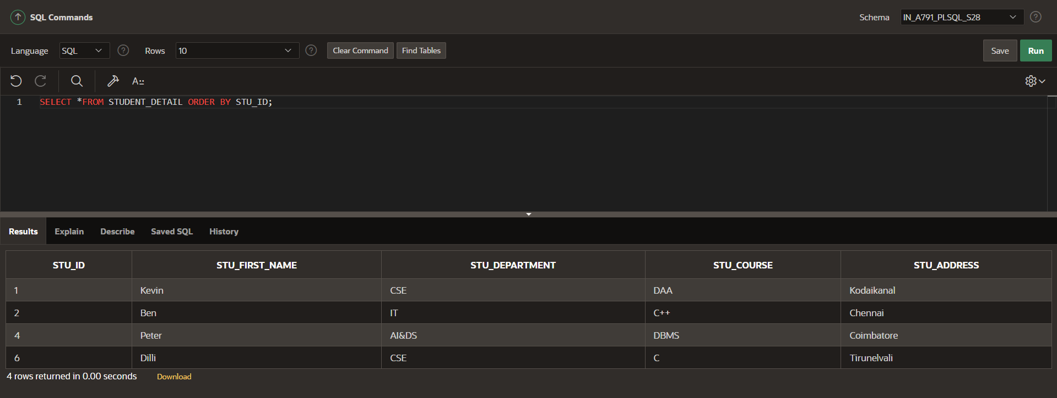

CREATE SYNONYM ST_DE FOR STUDENT_DETAIL;

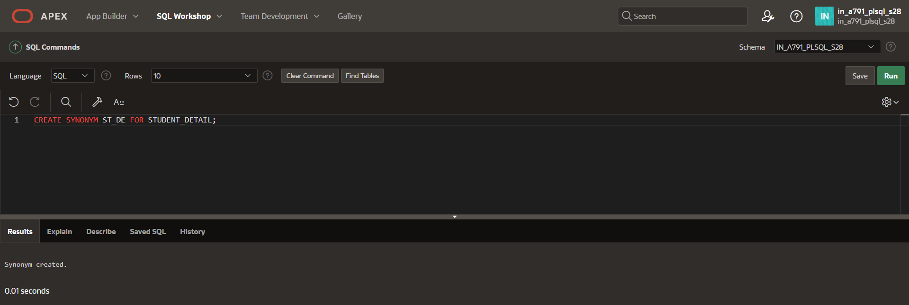

SELECT *FROM ST_DE;

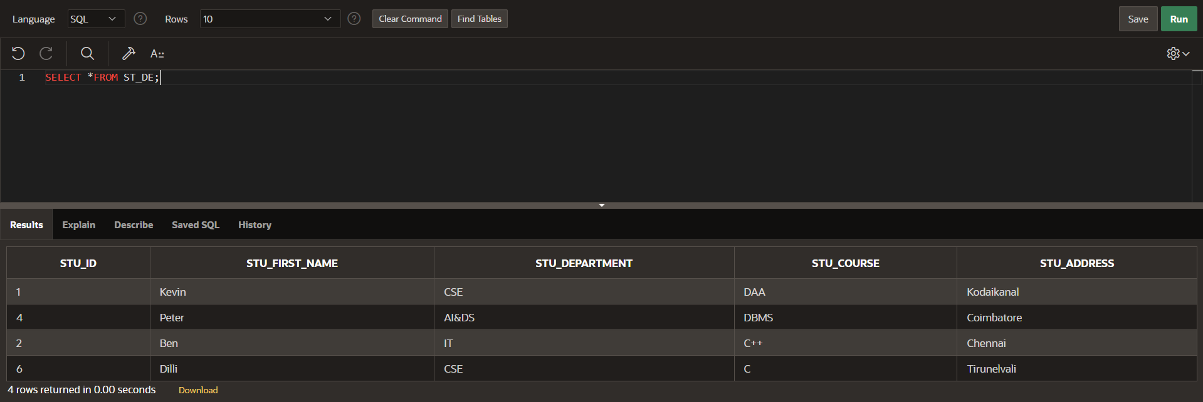

INSERT INTO ST_DE VALUES (7,'Ajith','AIML','OS','Trichy');

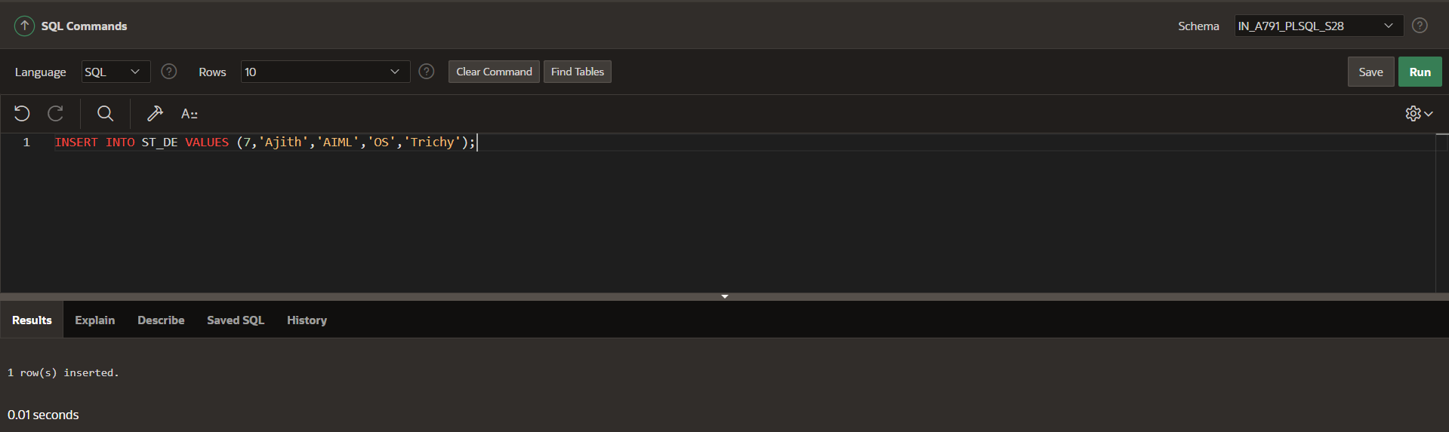

SELECT *FROM ST_DE;

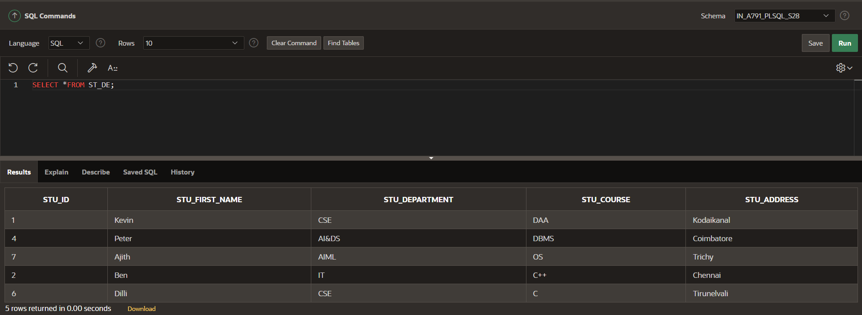

**DROP:**

